*Designing system components that support problem recognition, resistance, recovery, and reinstatement* For example, in an ambulance dispatch system, a watchdog timer (see Chapter 12) may be included to detect if the system is not responding to events. Operators may have to authenticate with a hardware token to resist the possibility of unauthorized access. If the system fails, calls may be diverted to another center so that the essential services are maintained. Copies of the system database and software on alternative hardware may be maintained to allow for reinstatement after an outageBaumer, D., G. Gryczan, R. Knoll, C. Lilienthal, D. Riehle, and H. Zullighoven. 1997. “Framework Development for Large Systems.” *Comm. ACM* 40 (10): 52–59. doi:10.1145/262793.262804. Boehm, B., and C. Abts. 1999. “COTS Integration: Plug and Pray?” *Computer* 32 (1): 135–138. doi:10.1109/2.738311.

Fayad, M.E., and D.C. Schmidt. 1997. “Object-Oriented Application Frameworks.” *Comm. ACM* 40 (10): 32–38.

doi:10.1145/262793.262798.

**Component-based software engineering**



# Objectives

The objective of this chapter is to describe an approach to software reuse based on the composition of standardized, reusable components. When you have read this chapter, you will:

■ understand what is meant by a software component that may be included in a program as an executable element;

■ understand the key elements of software component models and the support provided by middleware for these models;

■ be aware of the key activities in the component-based software engineering (CBSE) process for reuse and the CBSE process with reuse;

■ understand three different types of component composition and some of the problems that have to be resolved when components are composed to create new components or systems.

# Contents

**16.1** Components and component models

**16.2** CBSE processes

**16.3** Component composition

**206**

Chapter 16 ■ Component-based software engineering

Component-based software engineering (CBSE) emerged in the late 1990s as an approach to software systems development based on reusing software components. Its creation was motivated by frustration that object-oriented development had not led to extensive reuse, as had been originally suggested. Single-object classes were too detailed and specific and often had to be bound with an application at compiletime. You had to have detailed knowledge of the classes to use them, which usually meant that you had to have the component source code. Selling or distributing objects as individual reusable components was therefore practically impossible.

Components are higher-level abstractions than objects and are defined by their interfaces. They are usually larger than individual objects, and all implementation details are hidden from other components. Component-based software engineering is the process of defining, implementing, and integrating or composing these loosely coupled, independent components into systems.

CBSE has become as an important software development approach for largescale enterprise systems, with demanding performance and security requirements. Customers are demanding secure and dependable software that is delivered and deployed more quickly. The only way that these demands can be met is to build software by reusing existing components.

The essentials of component-based software engineering are:

1. Independent components that are completely specified by their interfaces. There should be a clear separation between the component interface and its implementation. This means that one implementation of a component can be replaced by another, without the need to change other parts of

the system.

1. Component standards that define interfaces and so facilitate the integration of components. These standards are embodied in a component model. They define, at the very minimum, how component interfaces should be specified and how components communicate. Some models go much further and define interfaces that should be implemented by all conformant components. If components conform to standards, then their operation is independent of their programming language. Components written in different languages can be integrated into the same system.
2. Middleware that provides software support for component integration. To make independent, distributed components work together, you need middleware support that handles component communications. Middleware for component support handles low-level issues efficiently and allows you to focus on application-related problems. In addition, middleware for component support may provide support for resource allocation, transaction management, security, and concurrency.
3. A development process that is geared to component-based software engineering. You need a development process that allows requirements to evolve, depending on the functionality of available components.

Component-based development embodies good software engineering practice. It often makes sense to design a system using components, even if you have to develop **Problems with CBSE**

CBSE is now a mainstream approach to software engineering and is widely used when creating new systems. However, when used as an approach to reuse, problems include component trustworthiness, component certification, requirements compromises, and prediction of the properties of components, especially when they are integrated with other components.

[**http://software-engineering-book.com/web/cbse-problems/**](http://software-engineering-book.com/web/cbse-problems)

rather than reuse these components. Underlying CBSE are sound design principles that support the construction of understandable and maintainable software:

1. Components are independent, so they do not interfere with each other’s operation. Implementation details are hidden. The component’s implementation can be changed without affecting the rest of the system.
2. Components communicate through well-defined interfaces. If these interfaces are maintained, one component can be replaced by another component providing additional or enhanced functionality.
3. Component infrastructures offer a range of standard services that can be used in application systems. This reduces the amount of new code that has to be developed.

The initial motivation for CBSE was the need to support both reuse and distributed software engineering. A component was seen as an element of a software system that could be accessed, using a remote procedure call mechanism, by other components running on separate computers. Each system that reused a component had to incorporate its own copy of that component. This idea of a component extended the notion of distributed objects, as defined in distributed systems models such as the CORBA specification (Pope 1997). Several different protocols and technology-specific

“standards” were introduced to support this view of a component, including Sun’s Enterprise Java Beans (EJB), Microsoft’s COM and .NET, and CORBA’s CCM (Lau and Wang 2007).

Unfortunately, the companies involved in proposing standards could not agree on a single standard for components, thereby limiting the impact of this approach to software reuse. It is impossible for components developed using different approaches to work together. Components that are developed for different platforms, such as .NET or J2EE, cannot interoperate. Furthermore, the standards and protocols proposed were complex and difficult to understand. This was also a barrier to their adoption.

In response to these problems, the notion of a component as a service was developed, and standards were proposed to support service-oriented software engineering. The most significant difference between a component as a service and the original notion of a component is that services are stand-alone entities that are external to a program using them. When you build a service-oriented system, you reference the external service rather than including a copy of that service in your system.

Service-oriented software engineering is a type of component-based software engineering. It uses a simpler notion of a component than that originally proposed in CBSE, where components were executable routines that were included in larger systems. Each system that used a component embedded its own version of that component. Serviceoriented approaches are gradually replacing CBSE with embedded components as an approach to systems development. In this chapter, I discuss the use of CBSE with embedded components; service-oriented software engineering is covered in Chapter 18.

# 16.1 Components and component models

The software reuse community generally agrees that a component is an independent software unit that can be composed with other components to create a software system. Beyond that, however, people have proposed varying definitions of a software component. Councill and Heineman (Councill and Heineman 2001) define a component as:

*A software element that conforms to a standard component model and can be independently deployed and composed without modification according to a composition standard.*[1]

This definition is standards-based so that a software unit that conforms to these standards is a component. Szyperski (Szyperski 2002), however, does not mention standards in his definition of a component but focuses instead on the key characteristics of components:

*A software component is a unit of composition with contractually-specified interfaces and explicit context dependencies only. A software component can be deployed independently and is subject to composition by third parties.*[2]

Both of these definitions were developed around the idea of a component as an element that is embedded in a system, rather than a service that is referenced by the system. However, they are equally applicable to service components.

Szyperski also states that a component has no externally observable state; that is, copies of components are indistinguishable. However, some component models, such as the Enterprise Java Beans model, allow stateful components, so these do not

correspond with Szyperski’s definition. While stateless components are certainly simpler to use, in some systems stateful components are more convenient and reduce system complexity.

What the above definitions have in common is that they agree that components are independent and that they are the fundamental unit of composition in a system. I think that, if we combine these proposals, we get a more rounded description of a reusable component. Figure 16.1 shows what I consider to be the essential characteristics of a component as used in CBSE.

|  |  |  |
| --- | --- | --- |
| **Component**  **characteristic** |  | **Description** |
| Composable |  | For a component to be composable, all external interactions must take place through publicly defined interfaces. In addition, it must provide external access to information about itself, such as its methods and attributes. |
| Deployable |  | To be deployable, a component has to be self-contained. It must be able to operate as a standalone entity on a component platform that provides an implementation of the component model. This usually means that the component is binary and does not have to be compiled before it is deployed. If a component is implemented as a service, it does not have to be deployed by a user of that component. Rather, it is deployed by the service provider. |
| Documented |  | Components have to be fully documented so that potential users can decide whether or not the components meet their needs. The syntax and, ideally, the semantics of all component interfaces should be specified. |
| Independent |  | A component should be independent—it should be possible to compose and deploy it without having to use other specific components. In situations where the component needs externally provided services, these should be explicitly set out in a “requires” interface specification. |
| Standardized |  | Component standardization means that a component used in a CBSE process has to conform to a standard component model. This model may define component interfaces, component metadata, documentation, composition, and deployment. |

**Figure 16.1** Component

characteristics A useful way of thinking about a component is as a provider of one or more services, even if the component is embedded rather than implemented as a service. When a system needs something to be done, it calls on a component to provide that service without caring about where that component is executing or the programming language used to develop the component. For example, a component in a system used in a public library might provide a search service that allows users to search the library catalog. A component that converts from one graphical format to another (e.g., TIFF to JPEG) provides a data conversion service and so on.

Viewing a component as a service provider emphasizes two critical characteristics of a reusable component:

1. The component is an independent executable entity that is defined by its interfaces. You don’t need any knowledge of its source code to use it. It can either be referenced as an external service or included directly in a program.
2. The services offered by a component are made available through an interface, and all interactions are through that interface. The component interface is expressed in terms of parameterized operations, and its internal state is never exposed.

In principle, all components have two related interfaces, as shown in Figure 16.2. These interfaces reflect the services that the component provides and the services that the component requires to operate correctly:

1. The “provides” interface defines the services provided by the component. This interface is the component API. It defines the methods that can be called by a user

**Provides interface**

Defines the

services that are needed andthat are provided should be provided by the component

**Requires interface**

servicesDefines the



**Figure 16.2** Component by other componentsto other components

interfaces

of the component. In a UML component diagram, the “provides” interface for a component is indicated by a circle at the end of a line from the component icon.

1. The “requires” interface specifies the services that other components in the system must provide if a component is to operate correctly. If these services are not available, then the component will not work. This does not compromise the independence or deployability of a component because the “requires” interface does not define how these services should be provided. In the UML, the symbol for a “requires” interface is a semicircle at the end of a line from the component icon. Notice that “provides” and “requires” interface icons can fit together like a ball and socket.

To illustrate these interfaces, Figure 16.3 shows a model of a component that has been designed to collect and collate information from an array of sensors. It runs autonomously to collect data over a period of time and, on request, provides collated data to a calling component. The “provides” interface includes methods to add, remove, start, stop, and test sensors. The report method returns the sensor data that has been collected, and the listAll method provides information about the attached sensors. Although I have not shown them here, these methods have associated parameters specifying the sensor identifiers, locations, and so on.

The “requires” interface is used to connect the component to the sensors. It assumes that sensors have a data interface, accessed through sensorData, and a management interface, accessed through sensorManagement. This interface has been designed to connect to different types of sensors so that it does not include specific sensor operations such as Test and provideReading. Instead, the commands used by a specific type of sensor are embedded in a string, which is a parameter to the operations in the “requires” interface. Adaptor components parse this parameter string and translate the embedded commands into the specific control interface of each type of sensor. I discuss the use of adaptors later in this chapter, where I show how the data collector component may be connected to a sensor (Figure 16.12).

|  |  |  |
| --- | --- | --- |
|  | **Requires interface** | **Provides interface** |
| **Figure** |  | **16.3** |

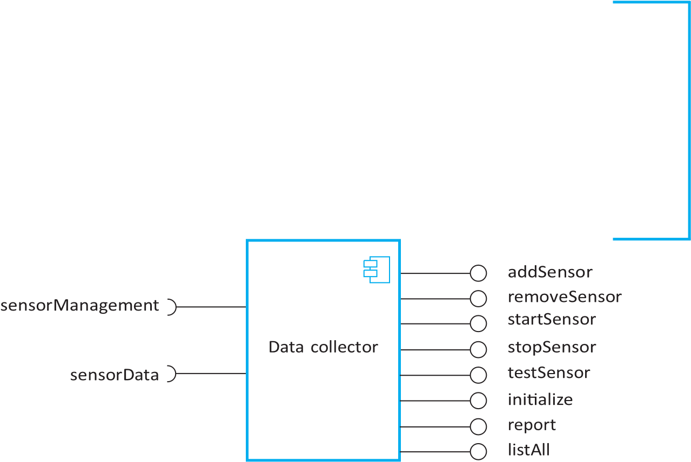

Components are often implemented in object-oriented languages, and, in some cases, accessing the “provides” interface of a component is done through method calls. However, components and object classes are not the same thing. Unlike object classes, components are independently deployable, do not define types, are languageindependent, and are based on a standard component model.

A model

**Components and objects**



[**http://software-engineering-book.com/web/components-and-objects/**](http://software-engineering-book.com/web/components-and-objects)

Components are accessed using remote procedure calls (RPCs). Each component has a unique identifier and, using this name, may be called from another computer. The called component uses the same mechanism to access the “required” components that are defined in its interface.

An important difference between a component as an external service and a component as a program element accessed using a remote procedure call is that services are completely independent entities. They do not have an explicit “requires” interface. Of course, they do require other components to support their operation, but these are provided internally. Other programs can use services without the need to implement any additional support required by the service.

## 16.1.1 Component models

A component model is a definition of standards for component implementation, documentation, and deployment. These standards are for component developers to ensure that components can interoperate. They are also for providers of component execution infrastructures who provide middleware to support component operation. For service components, the most important component model is the Web Service models, and for embedded components, widely used models include the Enterprise Java Beans (EJB) model and Microsoft’s .NET model (Lau and Wang 2007).

The basic elements of an ideal component model are discussed by Weinreich and Sametinger (Weinreich and Sametinger 2001). I summarize these model elements in Figure 16.4. This diagram shows that the elements of a component model define the component interfaces, the information that you need to use the component in a program, and how a component should be deployed:

1. *Interfaces* Components are defined by specifying their interfaces. The component model specifies how the interfaces should be defined and the elements, such as operation names, parameters, and exceptions, which should be included in the interface definition. The model should also specify the language used to define the component interfaces.

For web services, interface specification uses XML-based languages as discussed in Chapter 18; EJB is Java-specific, so Java is used as the interface definition language; in .NET, interfaces are defined using Microsoft’s Common

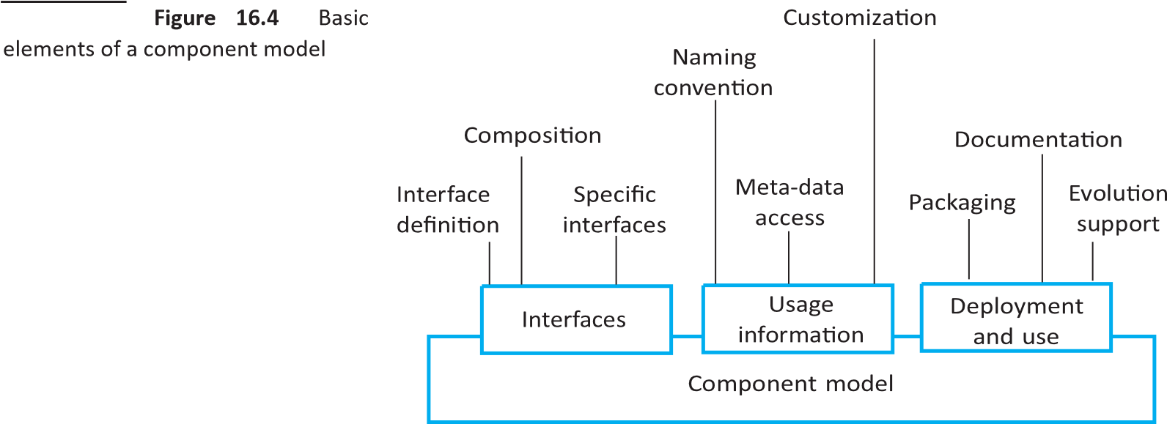

Intermediate Language (CIL). Some component models require specific interfaces that must be defined by a component. These are used to compose the component with the component model infrastructure, which provides standardized services such as security and transaction management.

1. *Usage* In order for components to be distributed and accessed remotely via RPCs, they need to have a unique name or handle associated with them. This has to be globally unique. For example, in EJB, a hierarchical name is generated with the root based on an Internet domain name. Services have a unique URI (Uniform Resource Identifier).

Component meta-data is data about the component itself, such as information about its interfaces and attributes. The meta-data is important because it allows users of the component to find out what services are provided and required. Component model implementations normally include specific ways (such as the use of a reflection interface in Java) to access this component meta-data.

Components are generic entities, and, when deployed, they have to be configured to fit into an application system. For example, you could configure the Data collector component (Figure 16.3) by defining the maximum number of sensors in a sensor array. The component model may therefore specify how the binary components can be customized for a particular deployment environment.

1. *Deployment* The component model includes a specification of how components should be packaged for deployment as independent, executable routines. Because components are independent entities, they have to be packaged with all supporting software that is not provided by the component infrastructure, or is not defined in a “requires” interface. Deployment information includes information about the contents of a package and its binary organization.

Inevitably, as new requirements emerge, components will have to be changed or replaced. The component model may therefore include rules governing when and how component replacement is allowed. Finally, the component model may define the component documentation that should be produced. This is used to find the component and to decide whether it is appropriate.

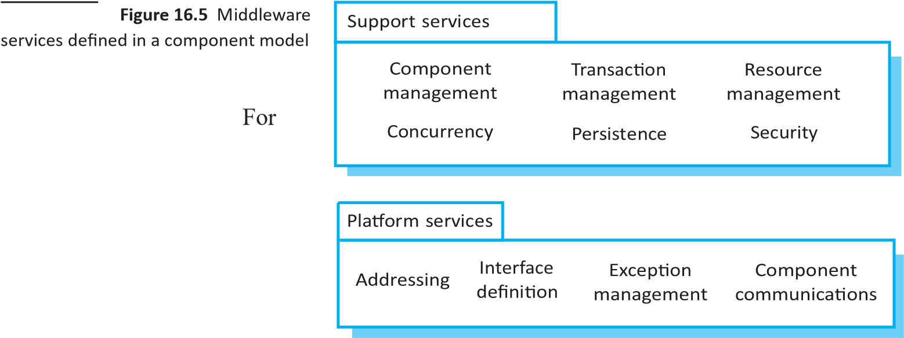

components that are executable routines rather than external services, the component model defines the services to be provided by the middleware that supports the executing components. Weinreich and Sametinger use the analogy of an operating system to explain component models. An operating system provides a set of generic services that can be used by applications. A component model implementation provides comparable shared services for components. Figure 16.5 shows some of the services that may be provided by an implementation of a component model.

The services provided by a component model implementation fall into two categories:

1. *Platform services*, which enable components to communicate and interoperate in a distributed environment. These are the fundamental services that must be available in all component-based systems.
2. *Support services*, which are common services that many different components are likely to require. For example, many components require authentication to ensure that the user of component services is authorized. It makes sense to provide a standard set of middleware services for use by all components. This reduces the costs of component development, and potential component incompatibilities can be avoided.

Middleware implements the common component services and provides interfaces to them. To make use of the services provided by a component model infrastructure, you can think of the components as being deployed in a “container.” A container is an implementation of the support services plus a definition of the interfaces that a component must provide to integrate it with the container. Conceptually, when you add a component to the container, the component can access the support services and the container can access the component interfaces. When in use, the component interfaces themselves are not accessed directly by other components. They are accessed through a container interface that invokes code to access the interface of the embedded component.

Containers are large and complex and, when you deploy a component in a container, you get access to all middleware services. However, simple components may

not need all of the facilities offered by the supporting middleware. The approach taken in web services to common service provision is therefore rather different. For web services, standards have been defined for common services such as transaction management and security, and these standards have been implemented as program libraries. If you are implementing a service component, you only use the common services that you need.

The services associated with a component model have much in common with the facilities provided by object-oriented frameworks, which I discussed in Chapter 15. Although the services provided may not be as comprehensive, framework services are often more efficient than container-based services. As a consequence, some people think that it is best to use frameworks such as SPRING (Wheeler and White 2013) for Java development rather than the fully-featured component model in EJB.

|  |
| --- |
| **16.2** |

# CBSE processes

CBSE processes are software processes that support component-based software engineering. They take into account the possibilities of reuse and the different process activities involved in developing and using reusable components. Figure 16.6 (Kotonya 2003) presents an overview of the processes in CBSE. At the highest level, there are two types of CBSE processes:

1. *Development for reuse* This process is concerned with developing components or services that will be reused in other applications. It usually involves generalizing existing components.
2. *Development with reuse* This process is the process of developing new applications using existing components and services.

These processes have different objectives and therefore include different activities. In the development for reuse process, the objective is to produce one or more reusable components. You know the components that you will be working with, and you have access to their source code to generalize them. In development with reuse, you don’t know what components are available, so you need to discover these components and design your system to make the most effective use of them. You may not have access to the component source code.

You can see from Figure 16.6 that the basic processes of CBSE with and for reuse have supporting processes that are concerned with component acquisition, component management, and component certification:

1. *Component acquisition* is the process of acquiring components for reuse or development into a reusable component. It may involve accessing locally developed components or services or finding these components from an external source.

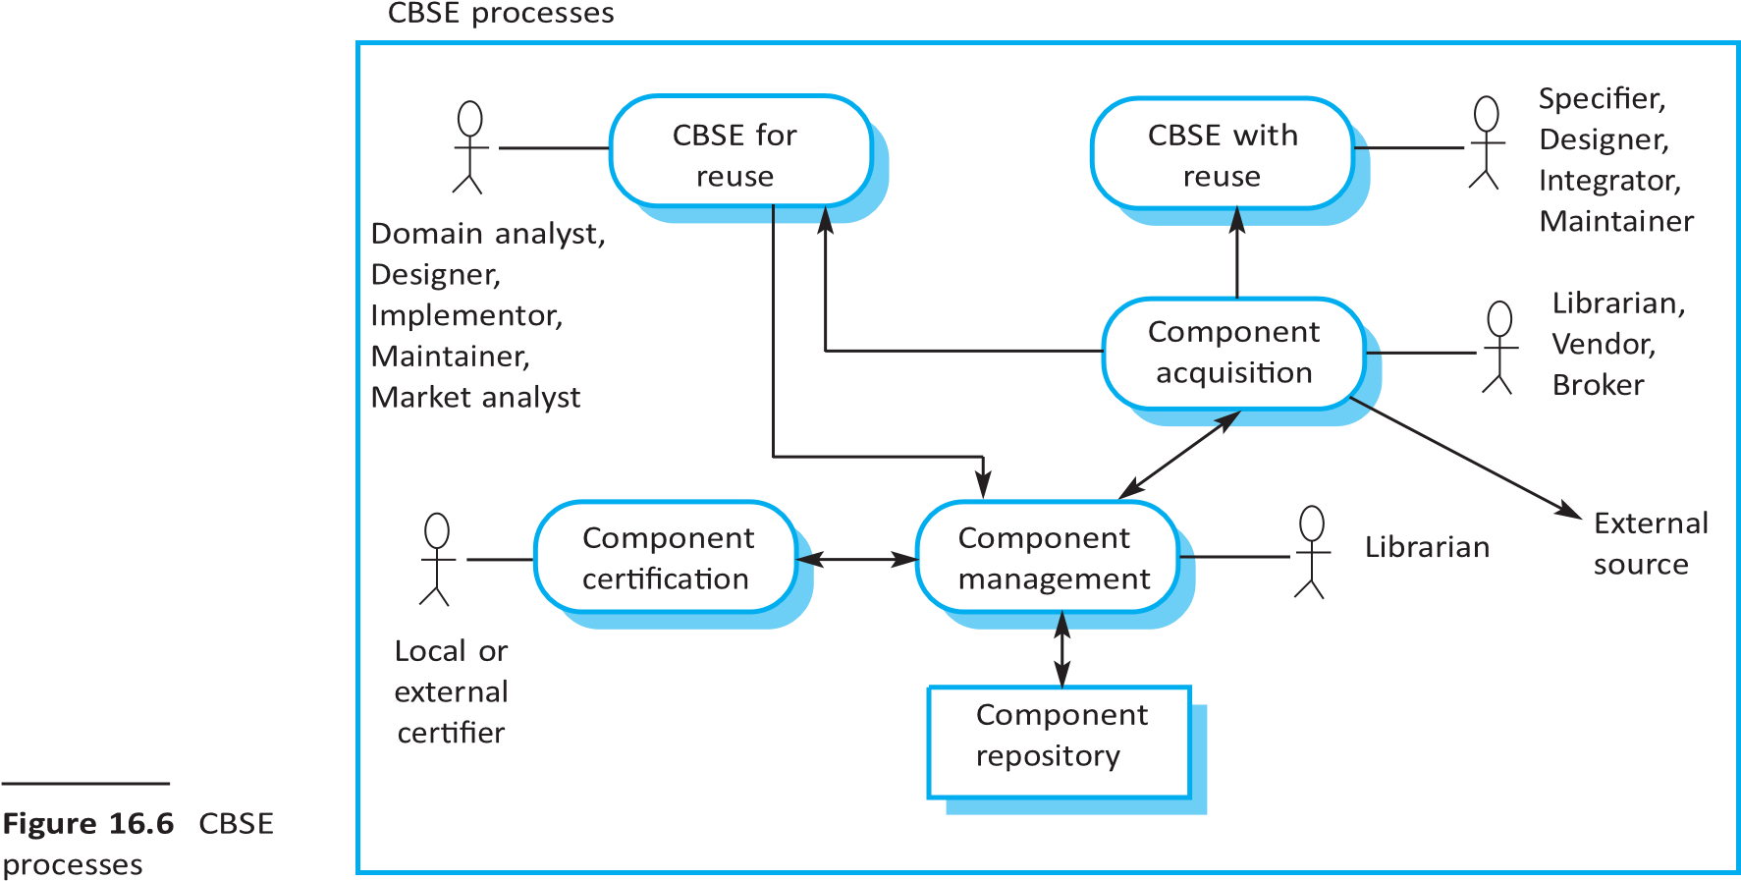

1. *Component management* is concerned with managing a company’s reusable components, ensuring that they are properly catalogued, stored, and made available for reuse.
2. *Component certification* is the process of checking a component and certifying that it meets its specification.

Components maintained by an organization may be stored in a component repository that includes both the components and information about their use.

## 16.2.1 CBSE for reuse

CBSE for reuse is the process of developing reusable components and making them available for reuse through a component management system. The vision of early supporters of CBSE (Szyperski 2002) was that a thriving component marketplace would develop. There would be specialist component providers and component vendors who would organize the sale of components from different developers. Software developers would buy components to include in a system or pay for services as they were used. However, this vision has not been realized. There are relatively few component suppliers, and buying off-the-shelf components is uncommon.

Consequently, CBSE for reuse is mostly used within organizations that have made a commitment to reuse-driven software engineering. These companies have a base of internally developed components that can be reused. However, these internally developed components may not be reusable without change. They often include application-specific features and interfaces that are unlikely to be required in other programs where the component is reused.

To make components reusable, you have to adapt and extend the applicationspecific components to create more generic and therefore more reusable versions. Obviously, this adaptation has an associated cost. You have to decide first, whether a component is likely to be reused and second, whether the cost savings from future reuse justify the costs of making the component reusable.

To answer the first of these questions, you have to decide whether or not the component implements one or more stable domain abstractions. Stable domain abstractions are fundamental elements of the application domain that change slowly. For example, in a banking system, domain abstractions might include accounts, account holders, and statements. In a hospital management system, domain abstractions might include patients, treatments, and nurses. These domain abstractions are sometimes called business objects. If the component is an implementation of a commonly used domain abstraction or group of related business objects, it can probably be reused.

To answer the question about cost-effectiveness, you have to assess the costs of changes that are required to make the component reusable. These costs are the costs of component documentation and component validation, and of making the component more generic. Changes that you may make to a component to make it more reusable include:

■ removing application-specific methods;

■ changing names to make them more general;

■ adding methods to provide more complete functional coverage;

■ making exception handling consistent for all methods;

■ adding a “configuration” interface to allow the component to be adapted to different situations of use; ■ integrating required components to increase independence.

The problem of exception handling is a difficult one. In principle, components should not handle exceptions themselves because each application will have its own requirements for exception management. Rather, the component should define what exceptions can arise and should publish these exceptions as part of the interface. For example, a simple component implementing a stack data structure should detect and publish stack overflow and stack underflow exceptions. In practice, however, there are two problems with this process:

1. Publishing all exceptions leads to bloated interfaces that are harder to understand. This may put off potential users of the component.
2. The operation of the component may depend on local exception handling, and changing this may have serious implications for the functionality of the component.

You therefore have to take a pragmatic approach to component exception handling. Common technical exceptions, where recovery is important for the functioning of the component, should be handled locally.

These exceptions and how they are handled should be documented with the component. Other exceptions that are related to the business function of the component should be passed to the calling component for handling.

Mili et al. (Mili et al. 2002) discuss ways of estimating the costs of making a component reusable and the returns from that investment. The benefits of reusing rather than redeveloping a component are not simply productivity gains. There are also quality gains, because a reused component should be more dependable, and time-to-market gains. These are the increased returns that accrue from deploying the software more quickly.

Mili et al. present various formulas for estimating these gains, as does the COCOMO model, discussed in Chapter 23. However, the parameters of these formulas are difficult to estimate accurately, and the formulas must be adapted to local circumstances, making them difficult to use. I suspect that few software project managers use these models to estimate the return on investment from component reusability.

Whether or not a component is reusable depends on its application domain, functionality, and generality. If the domain is a general one and the component implements standard functionality in that domain, then it is more likely to be reusable. As you add generality to a component, you increase its reusability because it can be applied in a wider range of environments. Unfortunately, this normally means that the component has more operations and is more complex, which makes the component harder to understand and use.

There is, therefore, a trade-off between the reusability and understandability of a component. To make a component reusable you have to provide a set of generic interfaces with operations that cater to all of the ways in which the component could be used. Reusability adds complexity and hence reduces component understandability. This makes it more difficult and time consuming to decide whether a component is suitable for reuse. Because of the time involved in understanding a reusable component, it is sometimes more costeffective to reimplement a simpler component with the specific functionality that is required.

A potential source of components is legacy systems. As I discussed in Chapter 9, legacy systems are systems that fulfill an important business function but are written using obsolete software technologies. As a result, it may be difficult to use them with new systems. However, if you convert these old systems to components, their functionality can be reused in new applications.

Of course, these legacy systems do not normally have clearly defined “requires” and “provides” interfaces. To make these components reusable, you have to create a wrapper that defines the component interfaces. The wrapper hides the complexity of the underlying code and provides an interface for external components to access services that are provided. Although this wrapper is a fairly complex piece of software, the cost of wrapper development may be significantly less than the cost of reimplementing the legacy system.

Once you have developed and tested a reusable component or service, it then has to be managed for future reuse. Management involves deciding how to classify the component so that it can be discovered, making the component available either in a repository or as a service, maintaining information about the use of the component, and keeping track of different component versions. If the component is open-source, you may make it available in a public repository such as GitHub or Sourceforge. If it is intended for use in a company, then you may use an internal repository system.

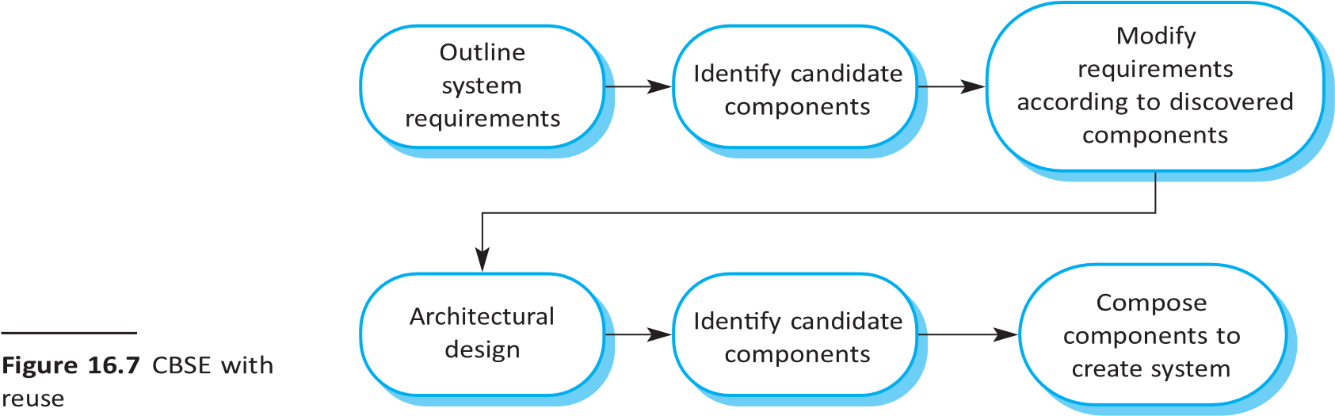

A company with a reuse program may carry out some form of component certification before the component is made available for reuse. Certification means that someone apart from the developer checks the quality of the component. They test the component and certify that it has reached an acceptable quality standard, before it is made available for reuse. However, this process can be expensive, and so many companies simply leave testing and quality checking to the component developers.

## 16.2.2 CBSE with reuse

The successful reuse of components requires a development process tailored to including reusable components in the software being developed. The CBSE with reuse process has to include activities that find and integrate reusable components. The structure of such a process was discussed in Chapter 2, and Figure 16.7 shows the principal activities within that process. Some of these activities, such as the initial discovery of user requirements, are carried out in the same way as in other software processes. However, the essential differences between CBSE with reuse and software processes for original software development are as follows:

1. The user requirements are initially developed in outline rather than in detail, and stakeholders are encouraged to be as flexible as possible in defining their requirements. Requirements that are too specific limit the number of components that could meet these requirements. However, unlike incremental development, you need a complete description of the requirements so that you can identify as many components as possible for reuse.
2. Requirements are refined and modified early in the process depending on the components available. If the user requirements cannot be satisfied from available components, you should discuss the related requirements that can be supported by the reusable components. Users may be willing to change their minds if this means cheaper or quicker system delivery.
3. There is a further component search and design refinement activity after the system



architecture has been designed. Apparently, usable components may turn out

**Figure 16.8**  The component identification process

to be unsuitable or may not work properly with other chosen components. You may have to find alternatives to these components. Further requirements changes may therefore be necessary, depending on the functionality of these components.

1. Development is a composition process where the discovered components are integrated. This involves integrating the components with the component model infrastructure and, often, developing adaptors that reconcile the interfaces of incompatible components. Of course, additional functionality may also be required over and above that provided by reused components.

The architectural design stage is particularly important. Jacobsen et al*.* (Jacobsen, Griss, and Jonsson 1997) found that defining a robust architecture is critical for successful reuse. During the architectural design activity, you may choose a component model and implementation platform. However, many companies have a standard development platform (e.g., .NET), so the component model is predetermined. As I discussed in Chapter 6, you also establish the high-level architecture of the system at this stage and make decisions about system distribution and control.

An activity that is unique to the CBSE process is identifying candidate components or services for reuse. This involves a number of subactivities, as shown in Figure 16.8. Initially, your focus should be on search and selection. You need to convince yourself that components are available to meet your requirements. Obviously, you should do some initial checking that the component is suitable, but detailed testing may not be required. In the later stage, after the system architecture has been designed, you should spend more time on component validation. You need to be confident that the identified components are really suited to your application; if not, then you have to repeat the search and selection processes.

The first step in identifying components is to look for components that are available within your company or from trusted suppliers. There are few component vendors, so you are most likely to be looking for components that have been developed in your own organization or in the repositories of open-source software that are available. Software development companies can build their own database of reusable components without the risks inherent in using components from external suppliers. Alternatively, you may decide to search code libraries available on the web, such as Sourceforge, GitHub, or Google Code, to see if source code for the component that you need is available.

Once the component search process has identified possible components, you have to select candidate components for assessment. In some cases, this will be a straightforward task. Components on the list will directly implement the user requirements, and there will not be competing components that match these requirements. In other cases, however, the selection process is more complex. There will not be a clear mapping of requirements onto components. You may find that several components have to be integrated to meet a

|  |
| --- |
| **The Ariane 5 launcher failure**  While developing the Ariane 5 space launcher, the designers decided to reuse the inertial reference software that had performed successfully in the Ariane 4 launcher. The inertial reference software maintains the stability of the rocket. The designers decided to reuse this without change (as you would do with components), although it included additional functionality that was not required in Ariane 5.  In the first launch of Ariane 5, the inertial navigation software failed, and the rocket could not be controlled. The rocket and its payload were destroyed. The cause of the problem was an unhandled exception when a conversion of a fixed-point number to an integer resulted in a numeric overflow. This caused the runtime system to shut down the inertial reference system, and launcher stability could not be maintained. The fault had never occurred in Ariane 4 because it had less powerful engines and the value that was converted could not be large enough for the conversion to overflow.  This illustrates an important problem with software reuse. Software may be based on assumptions about the context where the system will be used, and these assumptions may not be valid in a different situation.  More information about this failure is available at: [http://software-engineering-book.com/case-studies/ariane5/](http://software-engineering-book.com/case-studies/ariane5) |

**Figure 16.9** An example of validation failure with reused software

specific requirement or group of requirements. You therefore have to decide which of these component compositions provide the best coverage of the requirements.

Once you have selected components for possible inclusion in a system, you should then validate them to check that they behave as advertised. The extent of the validation required depends on the source of the components. If you are using a component that has been developed by a known and trusted source, you may decide that component testing is unnecessary. You simply test the component when it is integrated with other components. On the other hand, if you are using a component from an unknown source, you should always check and test that component before including it in your system.

Component validation involves developing a set of test cases for a component (or, possibly, extending test cases supplied with that component) and developing a test harness to run component tests. The major problem with component validation is that the component specification may not be sufficiently detailed to allow you to develop a complete set of component tests. Components are usually specified informally, with the only formal documentation being their interface specification. This may not include enough information for you to develop a complete set of tests that would convince you that the component’s advertised interface is what you require.

As well as testing that a component for reuse does what you require, you may also have to check that the component does not include malicious code or functionality that you don’t need. Professional developers rarely use components from untrusted sources, especially if these sources do not provide source code. Therefore, the malicious code problem does not usually arise. However, reused components may often contain functionality that you don’t need, and you have to check that this functionality will not interfere with your use of the component.

The problem with unnecessary functionality is that it may be activated by the component itself. While this may have no effect on the application reusing the component, it can slow down the component, cause it to produce surprising results or, in exceptional cases, cause serious system failures. Figure 16.9 summarizes a situation where the failure of a reused software system, which had unnecessary functionality, led to catastrophic system failure.

The problem in the Ariane 5 launcher arose because the assumptions made about the software for Ariane 4 were invalid for Ariane 5. This is a general problem with reusable components. They are originally implemented for a specific application environment and, naturally, embed assumptions about that environment. These assumptions are rarely documented, so when the component is reused, it is impossible to develop tests to check if the assumptions are still valid. If you are reusing a component in a new environment, you may not discover the embedded environmental assumptions until you use the component in an operational system.

|  |
| --- |
| **16.3** |

# Component composition

Component composition is the process of integrating components with each other, and with specially written “glue code” to create a system or another component. You can compose components in several different ways, as shown in Figure 16.10. From left to right these diagrams illustrate sequential composition, hierarchical composition, and additive composition. In the discussion below, I assume that you are composing two components (A and B) to create a new component:

1. *Sequential composition* In a sequential composition, you create a new component from two existing components by calling the existing components in sequence. You can think of the composition as a composition of the “provides interfaces.” That is, the services offered by component A are called, and the results returned by A are then used in the call to the services offered by component B. The components do not call each other in sequential composition but are called by the external application. This type of composition may be used with embedded or service components.

Some extra glue code may be required to call the component services in the right order and to ensure that the results delivered by component A are compatible with the inputs expected by component B. The “glue code” transforms these outputs to be of the form expected by component B.

1. *Hierarchical composition* This type of composition occurs when one component calls directly on the services provided by another component. That is, component A calls component B. The called component provides the services that are required by the calling component. Therefore, the “provides” interface of the called component must be compatible with the “requires” interface of the calling component.

Component A calls on component B directly, and, if their interfaces match, there may be no need for additional code. However, if there is a mismatch between the “requires” interface of A and the “provides” interface of B, then some conversion code may be required. As services do not have a “requires” interface, this mode of composition is not used when components are implemented as services accessed over the web.

**Figure 16.10**  Types of



component composition (1) (2) (3)

1. *Additive composition* This occurs when two or more components are put together (added) to create a new component, which combines their functionality. The “provides” interface and “requires” interface of the new component are a combination of the corresponding interfaces in components A and B. The components are called separately through the external interface of the composed component and may be called in any order. A and B are not dependent and do not call each other.

This type of composition may be used with embedded or service components.

You might use all the forms of component composition when creating a system. In all cases, you may have to write “glue code” that links the components. For example, for sequential composition, the output of component A typically becomes the input to component B. You need intermediate statements that call component A, collect the result, and then call component B, with that result as a parameter. When one component calls another, you may need to introduce an intermediate component that ensures that the “provides” interface and the “requires” interface are compatible.

When you write new components especially for composition, you should design the interfaces of these components so that they are compatible with other components in the system. You can therefore easily compose these components into a single unit. However, when components are developed independently for reuse, you will often be faced with interface incompatibilities. This means that the interfaces of the components that you wish to compose are not the same. Three types of incompatibility can occur:

* + 1. *Parameter incompatibility* The operations on each side of the interface have the same name, but their parameter types or the number of parameters are different. In Figure 16.11, the location parameter returned by addressFinder is incompatible with the parameters required by the displayMap and printMap methods in mapDB.
    2. *Operation incompatibility* The names of the operations in the provides and “requires” interfaces are different. This is a further incompatibility between the components shown in Figure 16.11.

16.3 ■ Component composition

**225**

3. *Operation incompleteness* The “provides” interface of a component is a subset of the “requires” interface of another component, or vice versa.

string location (string pn)



phoneDatabase (string command)

string owner (string pn)

string propertyType (string pn)

displayMap (string postCode, scale)

mapDB (string command)

printMap (string postCode, scale)

**Figure 16.11**

Components with incompatible interfaces

In all cases, you tackle the problem of incompatibility by writing an adaptor that reconciles the interfaces of the two components being reused. An adaptor component converts one interface to another.

The precise form of the adaptor depends on the type of composition. Sometimes, as in the next example, the adaptor takes a result from one component and converts it into a form where it can be used as an input to another. In other cases, the adaptor may be called by component A as a proxy for component B. This situation occurs if A wishes to call B, but the details of the “requires” interface of A do not match the details of the “provides” interface of B. The adaptor reconciles these differences by converting its input parameters from A into the required input parameters for B. It then calls B to deliver the services required by A.

To illustrate adaptors, consider the two simple components shown in Figure 16.11, whose interfaces are incompatible. These might be part of a system used by the emergency services. When the emergency operator takes a call, the phone number is input to the addressFinder component to locate the address. Then, using the mapper component, the operator prints a map to be sent to the vehicle dispatched to the emergency.

The first component, addressFinder, finds the address that matches a phone number. It can also return the owner of the property associated with the phone number and the type of property. The mapper component takes a post code (in the United States, a standard ZIP code with the additional four digits identifying property location) and displays or prints a street map of the area around that code at a specified scale.

These components are composable in principle because the property location includes the post or ZIP code. However, you have to write an adaptor component called postCodeStripper that takes the location data from addressFinder and strips out the post code. This post code is then used as an input to mapper, and the street map is displayed at a scale of 1:10,000. The following code, which is an example of sequential composition, illustrates the sequence of calls that is required to implement this process:

address = addressFinder.location (phonenumber) ; postCode =

postCodeStripper.getPostCode (address) ; mapper.displayMap(postCode, 10000) ;

Another case in which an adaptor component may be used is in hierarchical composition, where one component wishes to make use of another but there is an incompatibility

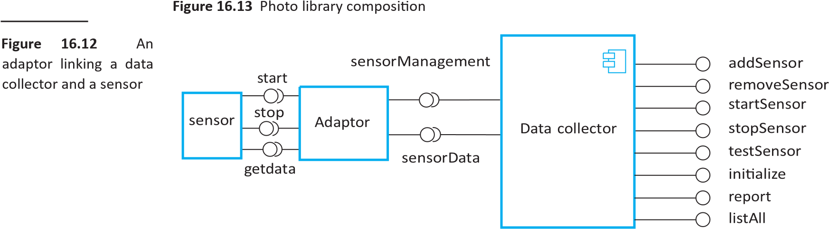

between the “provides” interface and “requires” interface of the components in the composition. I have illustrated the use of an adaptor in Figure 16.12 where an adaptor is used to link a data collector and a sensor component. These could be used in the implementation of a wilderness weather station system, as discussed in Chapter 7.

The sensor and data collector components are composed using an adaptor that reconciles the “requires” interface of the data collection component with the “provides” interface of the sensor component. The data collector component has been designed with a generic “requires” interface that supports sensor data collection and sensor management. For each of these operations, the parameter is a text string representing the specific sensor commands. For example, to issue a collect command, you would say sensorData(“collect”). As I have shown in Figure 16.12, the sensor itself has separate operations such as start, stop, and getdata.

The adaptor parses the input string, identifies the command (e.g., collect), and then calls Sensor.getdata to collect the sensor value. It then returns the result (as a character string) to the data collector component. This interface style means that the data collector can interact with different types of sensor. A separate adaptor, which converts the sensor commands from Data collector to the sensor interface, is implemented for each type of sensor.

The above discussion of component composition assumes you can tell from the component documentation whether or not interfaces are compatible. Of course, the interface definition includes the operation name and parameter types, so you can make some assessment of the compatibility from this. However, you depend on the

16.3 ■ Component composition **227**

component used to implement a system that downloads images from a camera and stores them documentation to in a photograph library. The system user can provide additional information to decide whether the describe and catalog the photograph. To avoid clutter, I have not shown all interface

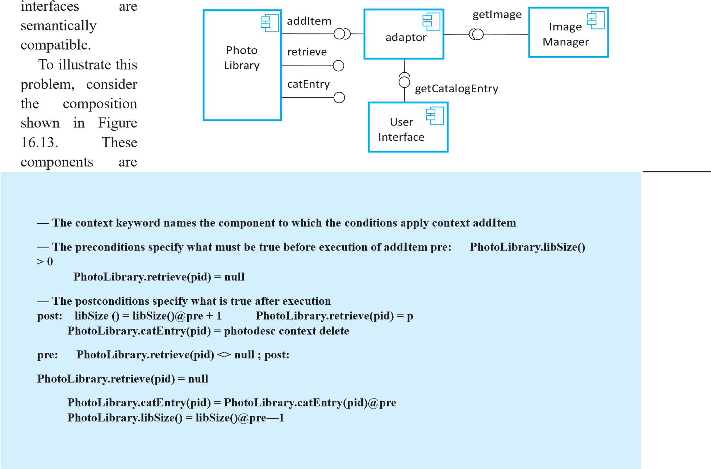

**Figure**

**16.14** The

OCL description of the Photo Library interface methods here. Rather, I simply show the methods that are needed to illustrate the component documentation problem. The methods in the interface of Photo Library are: public void addItem (Identifier pid ; Photograph p; CatalogEntry photodesc) ; public Photograph retrieve (Identifier pid) ; public CatalogEntry catEntry (Identifier pid) ;

Assume that the documentation for the addItem method in Photo Library is:

*This method adds a photograph to the library and associates the photograph identifier and catalog descriptor with the photograph.*

**228**  Chapter 16 ■ Component-based software engineering

This description appears to explain what the component does, but consider the following questions:

■ What happens if the photograph identifier is already associated with a photograph in the library?

■ Is the photograph descriptor associated with the catalog entry as well as the photograph? That is, if you delete the photograph, do you also delete the catalog information?

There is not enough information in the informal description of addItem to answer these questions. Of course, it is possible to add more information to the natural language description of the method, but in general, the best way to resolve ambiguities is to use a formal language to describe the interface. The specification shown in Figure 16.14 is part of the description of the interface of Photo Library that adds information to the informal description.

Figure 16.14 shows pre- and postconditions that are defined in a notation based on the object constraint language (OCL), which is part of the UML (Warmer and Kleppe 2003). OCL is designed to describe constraints in UML object models; it allows you to express predicates that must always be true, that must be true before a method has executed; and that must be true after a method has executed. These are invariants, preconditions, and postconditions. To access the value of a variable before an operation, you add @pre after its name. Therefore, using age as an example:

age = age@pre + 1 This statement means that the value of age after an operation is one more than it was before that operation.

OCL-based approaches are primarily used in model-based software engineering to add semantic information to UML models. The OCL descriptions may be used to drive code generators in model-driven engineering. The general approach has been derived from Meyer’s Design by Contract approach (Meyer 1992), in which the interfaces and obligations of communicating objects are formally specified and enforced by the runtime system. Meyer suggests that using Design by Contract is essential if we are to develop trusted components (Meyer 2003).

Figure 16.14 shows the specification for the addItem and delete methods in Photo Library. The method being specified is indicated by the keyword context and the pre- and postconditions by the keywords pre and post. The preconditions for addItem state that:

1. There must not be a photograph in the library with the same identifier as the photograph to be entered.
2. The library must exist—assume that creating a library adds a single item to it so that the size of a library is always greater than zero.
3. The postconditions for addItem state that:

The size of the library has increased by 1 (so only a single entry has been made).

If you retrieve using the same identifier, then you get back the photograph that you added.

16.3 ■ Component composition **229**

If you look up the catalog using that identifier, you get back the catalog entry that you made.

The specification of delete provides further information. The precondition states that to delete an item, it must be in the library, and, after deletion, the photo can no longer be retrieved and the size of the library is reduced by 1. However, delete does not delete the catalog entry—you can still retrieve it after the photo has been deleted. The reason for this is that you may wish to maintain information in the catalog about why a photo was deleted, its new location, and so on.

When you create a system by composing components, you may find that there are potential conflicts between functional and non-functional requirements, the need to deliver a system as quickly as possible, and the need to create a system that

(a)



**Figure 16.15**  Data collection and report (b) generation



components

can evolve as requirements change. You may have to take trade-offs into account for component decisions:

1. What composition of components is most effective for delivering the functional requirements for the system?
2. What composition of the components will make it easier to adapt the composite component when its requirements change?
3. What will be the emergent properties of the composed system? These properties include performance and dependability. You can only assess these properties once the complete system is implemented.

Unfortunately, in many situations the solutions to the composition problems may conflict. For example, consider a situation such as that illustrated in Figure 16.15, where a system can be created through two alternative compositions. The system is a data collection and reporting system where data is collected from different sources, stored in a database, and then different reports summarizing that data are produced.

Here, there is a potential conflict between adaptability and performance. Composition (a) is more adaptable, but composition (b) is likely to be faster and more reliable. The advantages of composition (a) are that reporting and data management are separate, so there is more flexibility for future change. The data management system could be replaced, and, if reports are required that the current reporting component cannot produce, that component can also be replaced without having to change the data management component.

**230**  Chapter 16 ■ Component-based software engineering

In composition (b), a database component with built-in reporting facilities (e.g., Microsoft Access) is used. The key advantage of composition (b) is that there are fewer components, so this will be a faster implementation because there are no component communication overheads. Furthermore, data integrity rules that apply to the database will also apply to reports. These reports will not be able to combine data in incorrect ways. In composition (a), there are no such constraints, so errors in reports could occur.

In general, a good composition principle to follow is the principle of separation of concerns. That is, you should try to design your system so that each component has a clearly defined role. Ideally, component roles should not overlap. However, it may be cheaper to buy one multifunctional component rather than two or three separate components. Furthermore, dependability or performance penalties may be incurred

1. Councill, W. T., and G. T. Heineman. 2001. “Definition of a Software Component and Its Elements.” In Component-Based Software Engineering, edited by G T Heineman and W T Councill, 5–20. Boston: Addison Wesley.
2. Szyperski, C. 2002. Component Software: Beyond Object-Oriented Programming, 2nd Ed. Harlow, UK: Addison Wesley.